SIMATS ENGINEERING
ASSESSMENT TOOL 1

COURSE NAME: Artificial Intelligence COURSE CODE: CSA17

COURSE OUTCOME COVERED

CO2: Experiment search and game-solving techniques such as Greedy Search, A*, CSP, Minimax, and Alpha-Beta pruning with heuristic functions for solving complex AI problems efficiently. (BL3)

Assessment Tool Weightage: 40%

Duration: 1 Hour
QUESTIONS: 3 Total Marks:30

Annexure A

Application Based Questions

Code of Conduct:

I MUKILAN K (192511437) (Name / Reg No) certify that this submission is my original work and that I have adhered to the guidelines specified for this assessment.
I understand that any violation of academic integrity rules will result in disciplinary action.

Signature of the student:

MUKILAN K

Annexure A

Application Based Questions

1. Intelligent Route Planning using A* and Greedy Search.
A smart delivery system is designed to transport medical supplies between cities. The system uses informed search strategies to determine optimal routes.
The road network is given below:
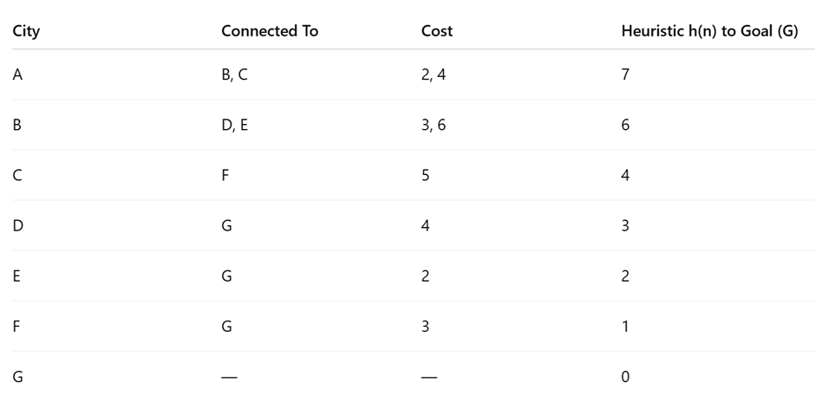
Tasks:
- Construct the search tree from A to G.
- Apply Greedy Best-First Search and show node expansion order.
- Apply A* algorithm using 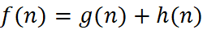.
- Justify which algorithm is better for real-time emergency delivery systems.
2. Constraint Satisfaction Problem – University Timetable Scheduling
A university must schedule final exams for 5 subjects: AI, ML, DBMS, OS, CN across 3 days (Day 1, Day 2, Day 3) with the conditions, AI and ML cannot be scheduled on the same day, DBMS must be scheduled before OS, CN cannot be on Day 1, At most 2 exams per day, A student is enrolled in AI, DBMS, and CN → these cannot overlap
Tasks:
- Formulate this problem as a Constraint Satisfaction Problem (CSP) by defining, Variables, Domains and Constraints
- Draw the constraint graph.
- Solve using Backtracking Search.
- Apply Forward Checking or Arc Consistency and explain how it reduces the search space.
- Provide one valid timetable solution.

3. Game Playing – Minimax and Alpha-Beta Pruning
An AI agent is designed to play a turn-based strategy game. The game tree is given below:
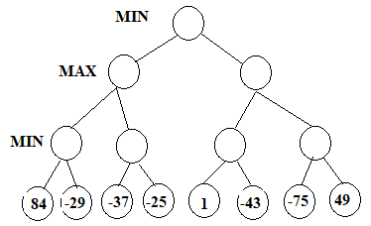
Tasks:
- Apply the Minimax algorithm and compute values for all internal nodes.
- Identify the optimal move for MAX.
- Apply Alpha-Beta Pruning to Show α and β values at each step and Clearly indicate which nodes are pruned
- Compare nodes evaluated in Minimax vs Alpha-Beta
- Explain the importance of evaluation functions in complex games like chess.

RUBRICS FOR CALCULATION

Criteria | Weightage | Level 4 – Exemplary | Level 3 – Proficient | Level 2 – Developing | Level 1 – Beginning
Understanding of Problem Context | 20 | Clearly understands the problem and accurately identifies all requirements | Good understanding with minor gaps | Basic understanding; some requirements unclear | Poor understanding or misinterpretation of the problem
Application of Concepts | 30 | Accurately applies appropriate concepts to solve complex problems | Applies relevant concepts correctly with minor errors | Applies basic concepts with limited accuracy | Fails to apply appropriate concepts
Problem-Solving Approach | 20 | Logical, well-structured, and efficient approach | Mostly logical approach with minor gaps | Basic approach with some inconsistencies | Illogical or unclear approach
Accuracy of Solution | 20 | Completely correct solution with proper justification | Mostly correct with minor errors | Partially correct solution | Incorrect or incomplete solution
Clarity | 10 | Clear, well-organized, and properly explained solution | Understandable with minor clarity issues | Limited clarity and explanation | Poorly presented and difficult to understand

Question 1: Intelligent Route Planning using A* and Greedy Search

i. Search Tree
A
/ \
B C
/ \ \
D E F
| | |
G G G

ii. Greedy Best-First Search
Heuristic values:
- A = 7
- B = 6
- C = 4
- D = 3
- E = 2
- F = 1
- G = 0
Node Expansion Order:

A → C → F → G

Path Found:

A → C → F → G

Total Cost = 4 + 5 + 3 = 12

iii. A* Search (f(n)=g(n)+h(n))

Node | g(n) | h(n) | f(n)
A | 0 | 7 | 7
B | 2 | 6 | 8
C | 4 | 4 | 8
D | 5 | 3 | 8
E | 8 | 2 | 10
F | 9 | 1 | 10
G (via D) | 9 | 0 | 9
Optimal Path:

A → B → D → G
Total Cost = 9

iv.Which algorithm is better?

A* is better because it considers both the actual path cost g(n) and heuristic value h(n). It always finds the optimal path, whereas Greedy Search only considers the heuristic and may produce a non-optimal route. Therefore, A* is preferred for emergency delivery systems.

Question 2: Constraint Satisfaction Problem (CSP)

i. Variables, Domains and Constraints

Variables:
AI, ML, DBMS, OS, CN
Domains:
{Day 1, Day 2, Day 3}
Constraints:
- AI ≠ ML
- DBMS before OS
- CN ≠ Day 1
- Maximum 2 exams per day
- AI, DBMS and CN should not be on the same day

ii. Constraint Graph

AI ------- ML
AI ------- DBMS ------- OS
\
CN
(CN is also constrained with AI and DBMS.)

iii. Backtracking Solution

Assign variables sequentially:
- AI → Day 1
- ML → Day 2
- DBMS → Day 2
- OS → Day 3
- CN → Day 3
All constraints are satisfied.

iv. Forward Checking

After assigning a variable, inconsistent values are removed from the remaining variables.
Example:
- AI = Day 1
- Remove Day 1 from ML.
- CN cannot be Day 1.
- This reduces unnecessary backtracking and speeds up the search.

v. Valid Timetable

Day | Subjects
Day 1 | AI
Day 2 | ML, DBMS
Day 3 | OS, CN

Question 3: Minimax and Alpha-Beta Pruning

Leaf nodes:
84, -29, -37, -25, 1, -43, -75, 49

i. Minimax Values
MIN Level:
- min(84, -29) = -29
- min(-37, -25) = -37
- min(1, -43) = -43
- min(-75, 49) = -75
MAX Level:
- max(-29, -37) = -29
- max(-43, -75) = -43
Root (MIN):
- min(-29, -43) = -43

ii. Optimal Move for MAX

MAX chooses:
- Left MAX = -29
- Right MAX = -43
Since -29 > -43, MAX chooses the left subtree.

iii. Alpha-Beta Pruning

Initial:
- α = −∞
- β = +∞
During evaluation:
- Left subtree evaluated completely.
- On the right subtree, after obtaining −43, remaining branches whose values cannot improve the result are pruned.
Pruned Node: 49

iv. Comparison

Algorithm | Nodes Evaluated
Minimax | 8 leaf nodes
Alpha-Beta | 7 leaf nodes (1 node pruned)
Alpha-Beta is more efficient because it avoids evaluating unnecessary nodes while giving the same optimal result.

v. Importance of Evaluation Functions

Evaluation functions estimate the quality of a game position when searching the complete game tree is impossible. In games like chess, they consider factors such as material advantage, king safety, board control, and mobility, enabling the AI to make strong decisions efficiently.

